Creating the Grating Couplers
- Began with the initial ‘grating coupler’ from the application gallery
- Materials set for each component
- Model set for 0.78 and ports
- Run calculations on papers. And assumptions
  - Grating phase matching - pitch
    - Assume fibre angle (10) – get reference
    - Fibre core/cladding effective index (1.44427 and 1.43482) – get reference
    - Wavelength 0.78um
    - M = 1 – explain
  - Fibre x pos in middle
  - Duty cycle = 0.5
  - Etch depth ?
  - Assume taper length

- 2d sweeping fibre x position, duty cycle, etch depth, pitch

- 2d optimization

- Shape of grating teeth , widen and also bend (coned shape)

- 3D sweep fibre x position, duty cycle, etch depth, pitch,

Initial Beginning
I began initially through the ‘Grating Coupler’ in the application gallery in Ansys Optics Launcher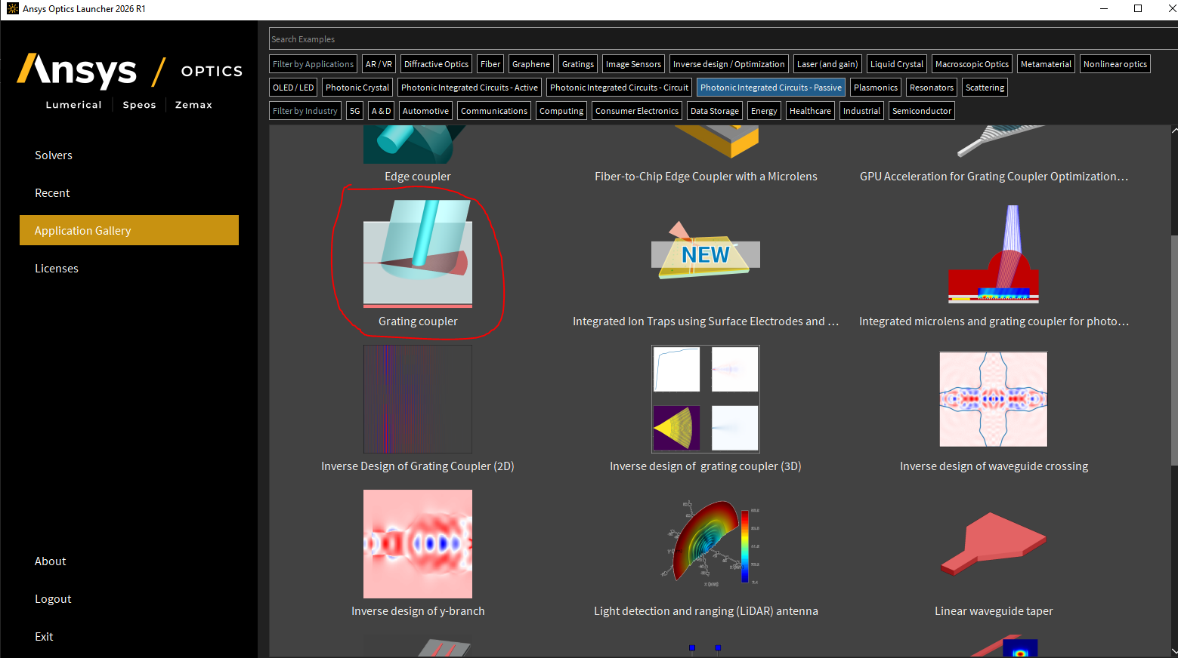
This provided a decent structure to work with.
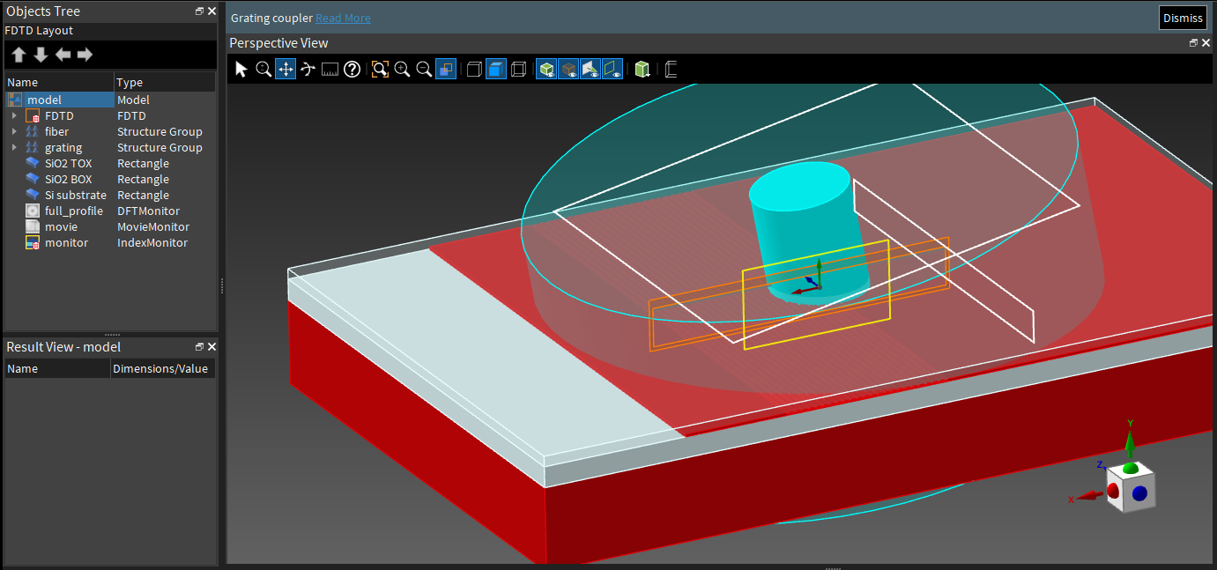
gave initial fibre, grating, silicon oxide top and bottom, silicon substrate to edit to improve efficiency,

FOM
The way we measure efficiency of the coupling is how much of the light from port 1 (the white line encompassed by black) reaches port 2 (the white line encompassed by green). We’ll Call this the FOM value (Figure Of Merit) and it’ll be normalized , so the max it can be is 1.
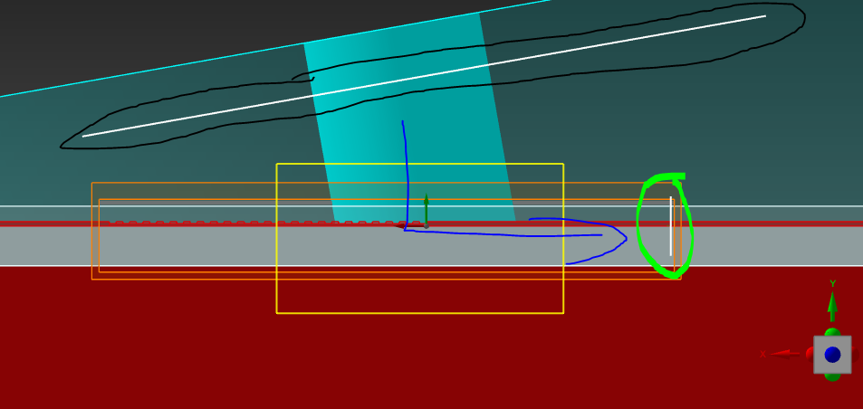
The way this is calculated is in the Model Script, in the objects tree select model > edit > Analysis > Script :
## Normalized power through port 2 at the target frequency.
## This result is needed to optimize the coupling efficiency.

T_data = getresult("::model::FDTD::ports::port 2","T");
T = abs(T_data.T);
lambda = T_data.lambda;
#lambda0 = (min(lambda)+max(lambda))/2.0;
ii = find(lambda,lambda0);
?T = T(ii);

Setting material and wavelength

Grating Material
Team decided we’ll have the actual component made of Silicon Nitride (Si3N4), and the top/bottom oxide mad of Silicon Oxide (SiO2). First make sure these materials are in the Database, go to Design > Database and see if its there.
Now, In the objects tree, Grating > edit > set material to ‘Si3N4 (Silicon Nitride) – Phillip’ 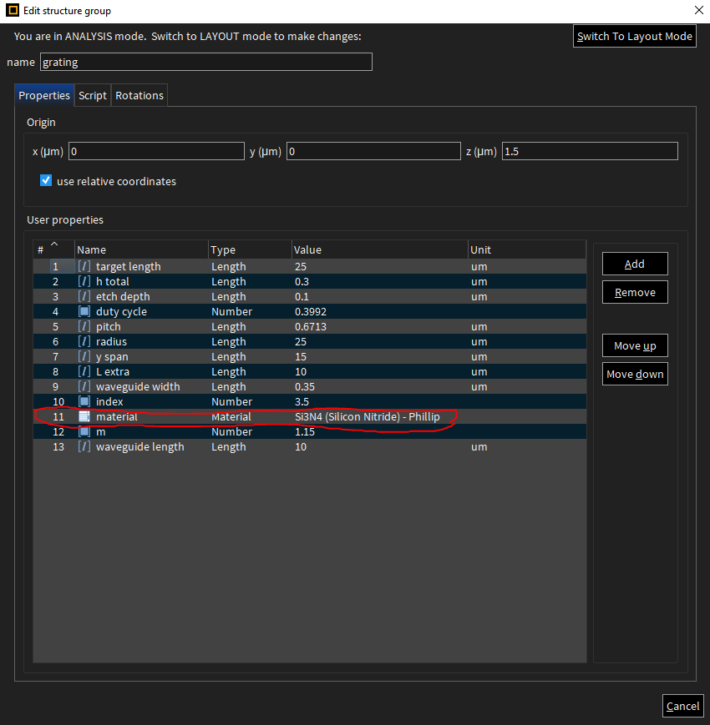

Silicon Top/ Bottom/Substrate Material
And set the SiO2 TOX, SiO2 BOX material to = ‘SiO2 (Glass) – Palik’ 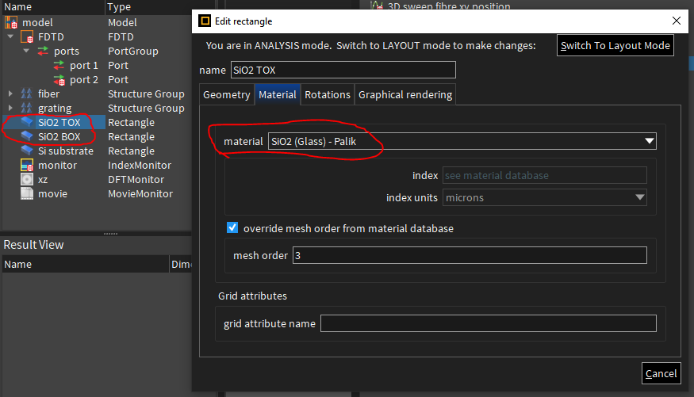
And Finally in Silicon Substrate, set the material to just ‘ Si (Silicon) – Palik’

Wavelength set up
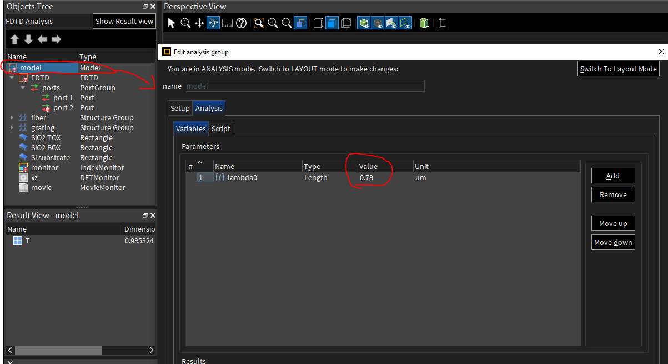
We are creating a 4x4 unitary using 0.78um Wavelength, so we need to set the wavelength we are producing and detecting is 0.78. We need to change the detected wavelength in the model. Select Model > Analysis > Variables set lambda0 value = 0.78, unit = um.

In the FDTD solver, FDTD > edit > Advanced Options, set the wavelength to only 0.78.
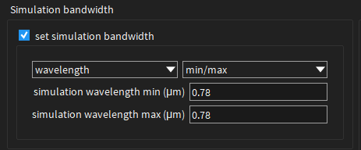

Also, in FDTD > ports > edit > in source settings and in monitor settings.
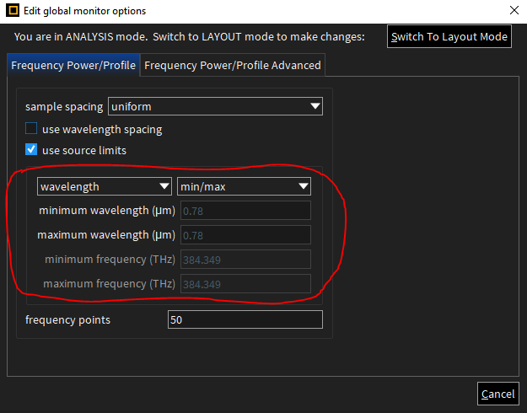
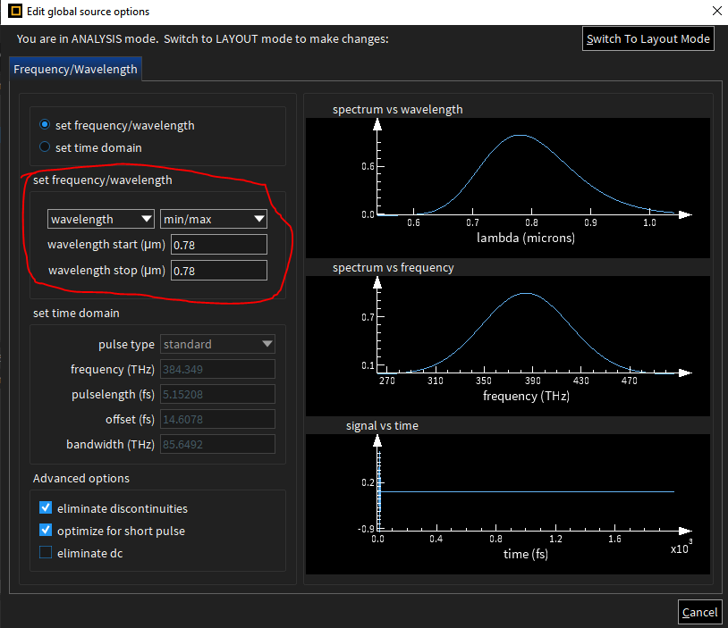

Assumptions and Estimations

Which properties are to be optimized / are static
Some properties have to remain the same no matter what to fit the rest of the components, and also due to fabrication restrictions/ agreements.
Static properties
- Waveguide width = 0.35um
- Waveguide height = 0.3um
- Silicon oxide top height = 2um
- Silicon oxide bottom height = 3um
Optimized properties
- Fibre Angle
- Fibre core/cladding diameter
- Etch depth
- Pitch
- Grating width / length
- Fibre position
- Period number
- Duty Cycle
- Grating overall shape / taper length

Initial assumed values

Fibre Angle
I assume a fibre angle of 10° (meaning it leans in the direction of port 2 – see image below. I chose 10° due to an extensive number of papers stating it’s an optimal starting position and provides a fair starting point
- 1.( (Kumar Selvaraja et al., n.d.) “Both the fibers were positioned at an angle of 10 degrees.”
- 2. (Chen, J. Thomson and Crudginton, 2017) “Fibres were aligned to the surface of the SOI wafer with a tilting angle of θ =100 off norma”

Fibre Core/Cladding diameter
Core diameter = 9um and cladding diameter = 50um
- 3 (OPTICAL FIBERS Features, n.d.)

Etch Depth
The Etch depth is the depth of the grating teeth. The total heigh of the teeth will be 0.3um, so a safe initial value can be 0.15um.

Duty cycle

Pitch
Pitch is the size of one period, which is the tooth width + gap width. We can calculate what the pitch should be around using the grating phase matching equation
$$\frac{mℷ}{(neff-nclad)*(\sin{θ})}$$
- m = diffraction order (1)
- $ℷ$ = wavelength we are coupling (0.78um)
- $neff$ = effective index of optical mode (1.6496)
- $nclad$ = effective index of cladding (1.44)
- $θ$ = fibre angle to normal (grating) (10)
We get the value 0.558um so we will set the value initially to this.

Grating width / length
Set to 25um, this isn’t a very important factor, as long as it’s big enough to fit the entire fibre core. I doubt it will change much.

Fibre Position
The position of the fibre core on the grating region, initially we set it to the middle of the grating length , so around 12.5um.

Period number
Calculated by total grating length / pitch. For the initial values it will be 25 / 0.558 = 44.8, round up to 45. Is not set directly

Duty Cycle
This value is the fraction of how much of one pitch is occupied by the tooth. It lies between 0 – 1. Initially we will set it to 0.5.

Grating overall shape / taper length
The shape initially is rectangular shaped, but I assume later it will be more cone shaped / the grating teeth will be bent rather than straight

Initial shape

2nd Version
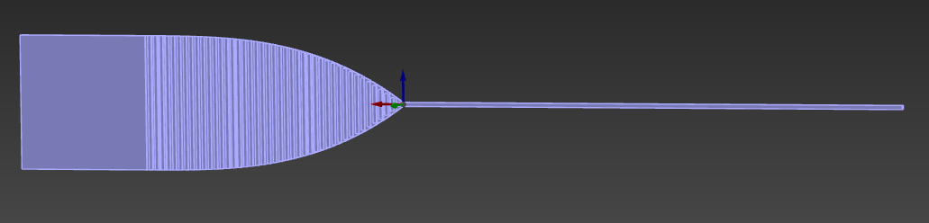

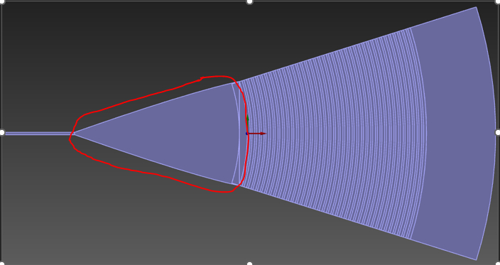
Later version (I expect) I say I expect I ended up doing. Also, a taper will be added, which is the area between the grating area and the waveguide ( the area circled)

2D Simulations
Sweeps are used for a broad range of values, to find the general area. Also, we remain in a 2D simulation for much more simpler calculations.

Sweeping

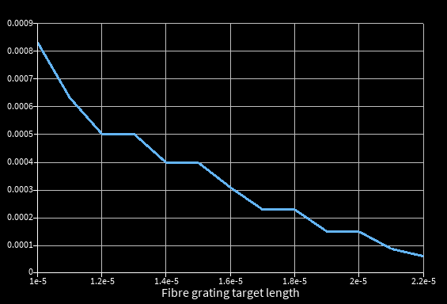
Fibre x position

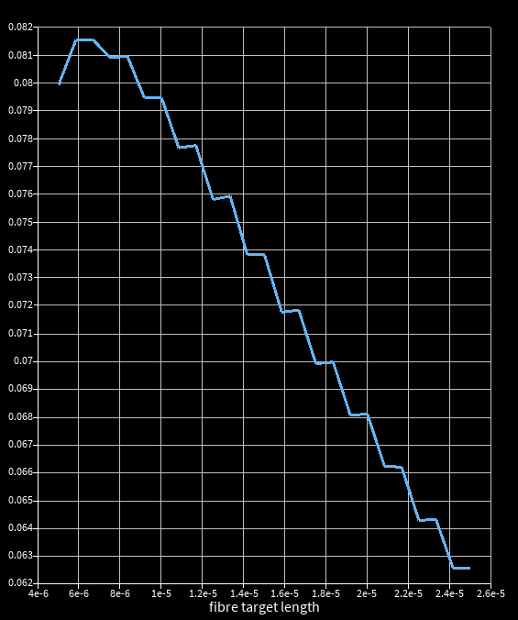

References
- Kumar Selvaraja, S., Vermeulen, D., Schaekers, M., Sleeckx, E., Bogaerts, W., Roelkens, G., Dumon, P., Thourhout, V. and Baets, R. (n.d.). Highly efficient grating coupler between optical fiber and silicon photonic circuit. [online] Available at: https://www.photonics.intec.ugent.be/download/pub_2380.pdf [Accessed 9 Apr. 2026].

- Chen, X., J. Thomson, D. and Crudginton, L. (2017). Dual-etch apodised grating couplers for efficient fibre-chip coupling near 1310 nm wavelength. [online] ResearchGate. Available at: https://www.researchgate.net/publication/317843312_Dual-etch_apodised_grating_couplers_for_efficient_fibre-chip_coupling_near_1310_nm_wavelength [Accessed 9 Apr. 2026].

- OPTICAL FIBERS Features. (n.d.). Available at: https://www.ozoptics.com/ALLNEW_PDF/DTS0135.pdf [Accessed 9 Apr. 2026].

‌

